Welcome to the world of BASH
bash is an acronym that stands for borne again shell
bash was designed to replace the much simpler “Bourne Shell” or sh
A shell is a terminal. Here is an example: 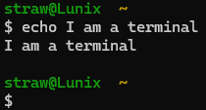
The terminal or shell is distinct from the desktop. Below is a desktop GUI:
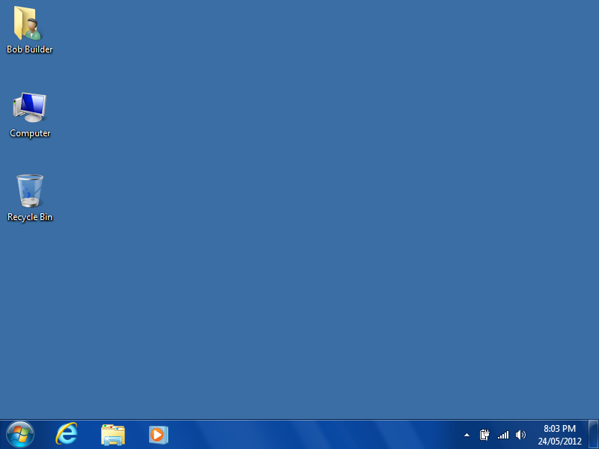 or 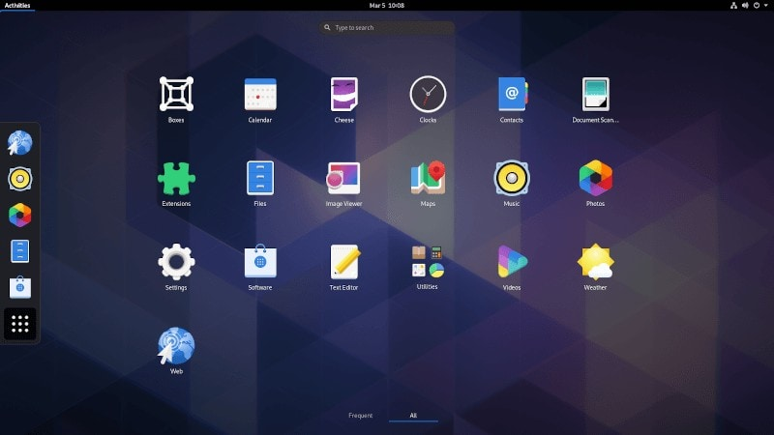
Note: bash is installed by default on almost every Linux operating system, in windows it must be installed because windows utilizes a different terminal language known as Power Shell by default.
- Making your first file
- To begin shattering the veil cast over our eyes by the comforting desktop interface let us open a terminal:
- For Windows see the bash installation guide for windows here.
On Linux (Debian based) open the terminal with the keyboard shortcut Ctrl + Alt + t
- Now that the terminal is open type the command ‘help’ and press enter/return. Here you will see a large number of commands and helpful hints for learning them. Now type ‘clear’ and press enter/return.
- Now type the command ‘ls’ and press enter. “ls” stands for “list”. You should see many files and some directories too. Type ‘clear’ and press enter then type ‘ls -l’ and press enter. Ls -l means “long list” or “list long” as you can see it is longer and contains much more info than the ‘ls’ command did.
- Type the command ‘touch file1’ and press enter. You’ve just created a file. Enter the command ‘ls’ again. You should see a file named file1. Type cat file1. You should see nothing shown in the terminal: That is because “cat” lists all the text information contained in a file. Enter the ‘clear command’
- Enter the command ‘vim file1’
- If you don’t have vim installed on a Debian based operating system such as Ubuntu enter ‘sudo apt install vim’ and try again.
Press ‘i’ you should now be in insert mode. Now type out a statement such as “Hello World!” From here, press the escape key esc then press shift and hit the colon key then let go of shift and type wq. “wq” stands for write and then quit. Now type the command ‘cat file1’.
II. Navigating Directory Hierarchies
- Enter the command ‘cp file1 mytext1’. “cp” stands for copy. Enter ‘ls’ to see the results. Enter the command ‘cat mytext1’, notice it is the same as file1.
- Enter the command ‘mkdir Directory1’: enter ‘ls’ to see the results. “mkdir” stands for make directory. Next type ‘cd Directory1’: “cd” stands for “change directory”. Enter ‘ls’ and notice that this new directory is empty. Further, your terminal should look something like this now: 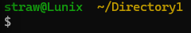 The ~ means “home directory” you are now in the subdirectory “Directory1”. Enter ‘mkdir subDirectory1’ then ‘cd subDirectory1’. Now your terminal should look a little different:
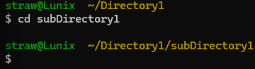
Let’s read what this means in human English. Your current command line is located within the “subDirectory” folder which is contained within the “Directory1” folder which itself is located within the home directory like so: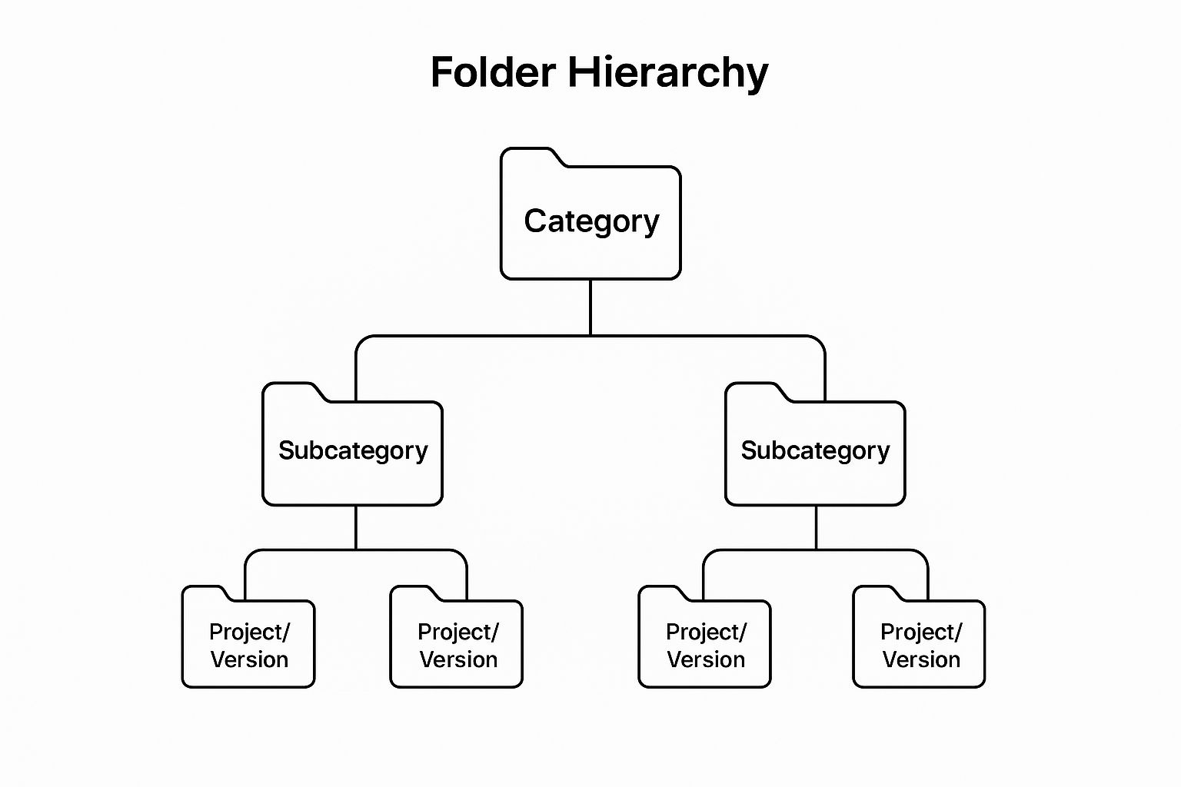
- Now enter ‘cd ..’

